Android PHone Remote Pointing Device

Supervisor: Dr Paul Scott 2nd Assessor: Dr Sam Steel

Author: Jenothan Premarajah

Interim Report

Content

1. Introduction 2
2. Goals 2
   1. Project Goal 2
   2. System Goal 2
   3. Methodology 3
3. Introduction

This report

1. Revised Background Reading
2. Revised Goals
3. Agile v Waterfall
4. Requirements

4.1 Functional

* The android phone has to be able to control the mouse cursor of the computer

4.2 Non-Functional

* No more than 1 android phone should connect to the computer

1. Specification

7.1 Bluetooth

1. Release Planning
2. Sprints

8.1 Sprint 1

Deliverable – Client-server Bluetooth communication

- Server-side GUI

Design - 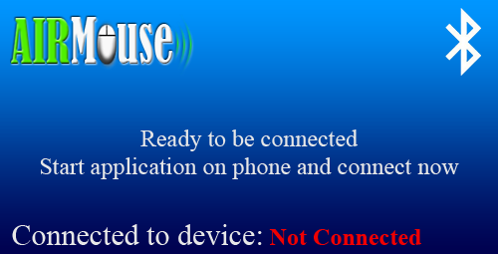

8.2 Sprint 2

Deliverable – Mouse mode implementation. Controlling the mouse cursor of a computer remotely, using the android phone.

- Mouse mode GUI on client’s side

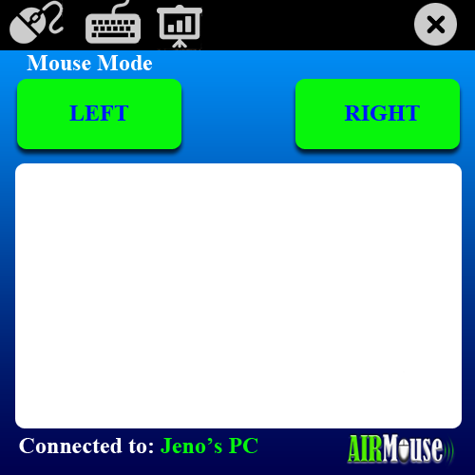Design –

8.3 Sprint 3

Deliverable –Keyboard mode implementation. Remote keyboard input to the computer using the android phone.

- Keyboard mode GUI on client’s side

Design –

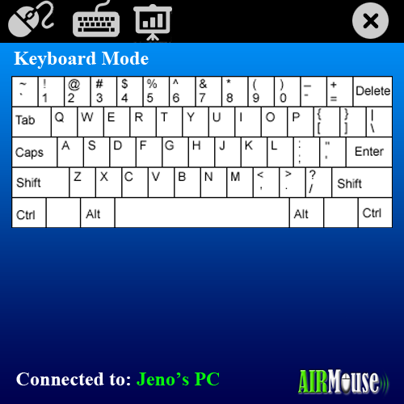

8.4 Sprint 4

Deliverable – Presentation mode implementation. Allowing a user to control slides on a PowerPoint presentation such as next slide, previous slide, full-screen and normal view.

- Presentation mode GUI on client’s side.

Design -

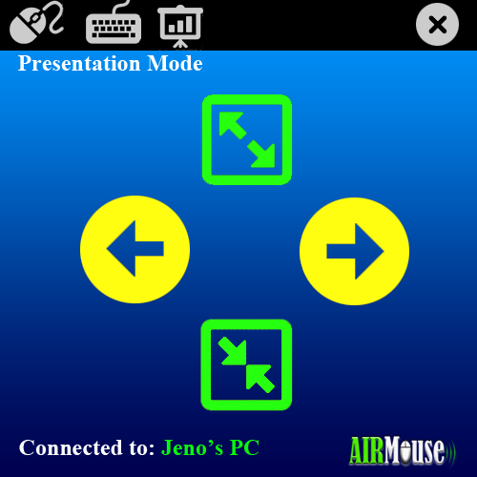

1. Gantt Chart
2. Conclusion
3. References